**Concept Prototype Performance:**

A recommended approach for continued technology development can be provided by comparing the test results of the three conceptual prototypes (A, B, and C) to the established Overall Measures of Effectiveness (OMOEs ). In order to determine which of the three prototypes has most effectively achieved the OMOEs, test data was compiled and analyzed using Analysis of Variance (ANOVA), descriptive statistics and box plots.

The first step of the analysis was to evaluate the test results (including Mission Reliability, Refueling Time, DRM Elapsed Time, and Deployed-to-Ready Time) calculated Operational Availability, and measured system characteristics (including Vehicle Weight, Vehicle Drop Height, Storage Container Volume, and Operational Team Size) against Key Performance Parameters (KPPs). This comparison was conducted using ANOVA. Utilizing this method of analysis allowed each system to be compared by its statistical similarity to KPPs.

The ANOVA results indicate that all three prototypes failed to show statistical similarity to KPPs – this is expected as these systems are still prototypes and require increased maturity. However, the results also indicate which of the three prototypes is the closest to meeting KPPs. Because each prototype, on average, was able to meet or exceed the threshold KPPs, the ANOVA focused on comparison to KPP goal values.

The ANOVA outputs for each prototype can be seen below:



Based on the results, prototype B is statistically “most similar” to the KPP goal values. Its associated ANOVA output indicates the lowest P-value when compared to prototypes A and C. Descriptive statistics and box plots were also used to gain additional prototype performance insights.

Box plots allow for quick visual comparisons of test data and help to verify the findings discovered through ANOVA. In order to create box plots for each of the KPPs, descriptive statistics were generated and used as input. The box plots created as a result of this analysis can be seen below:

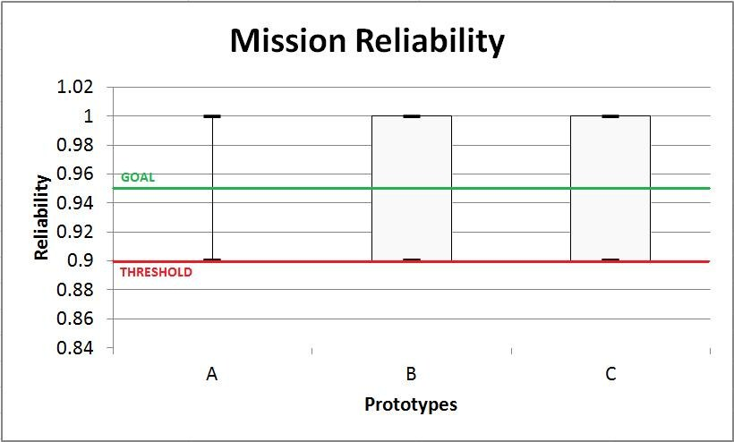

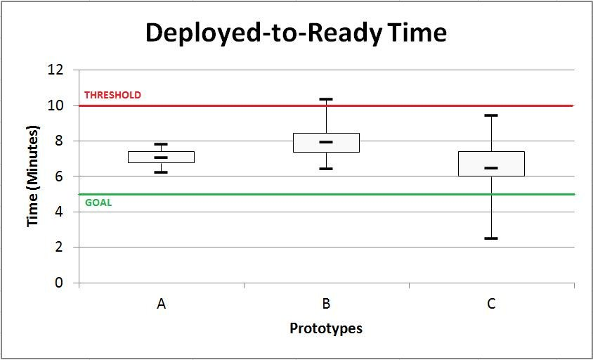

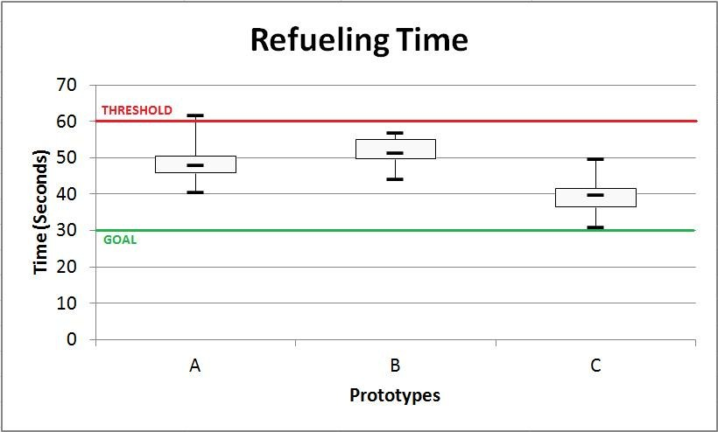

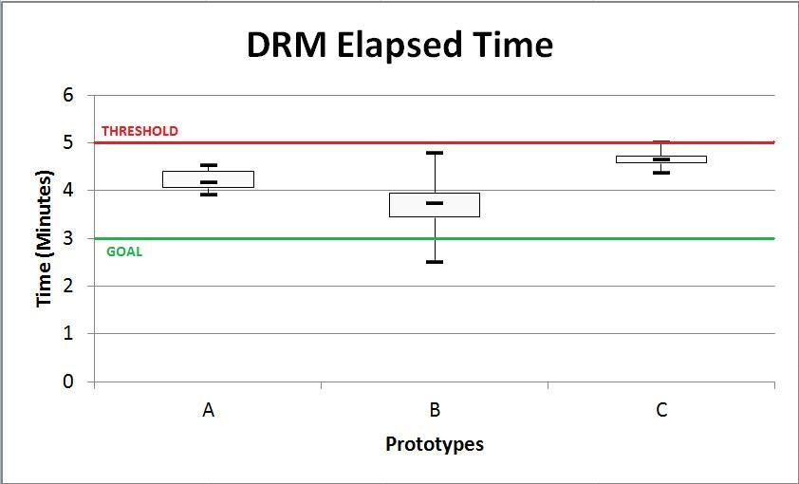

The box plots depict the median, minimum, maximum and inter-quartile range for a given set of data. In this regard they are especially useful as they allow for a more accurate analysis of a data set than the plot of averages alone. Based on the box plots it is evident that prototypes B and C are consistently the best performing and closest to the goal values for each metric. If prototype selection was solely based on a visual analysis of box plots, one would recommend variant C for its strong Refueling Time and Deployed-to-Ready-Time. On the other hand, the ANOVA analysis above indicated prototype B as the most statistically similar, therefore a more complete analysis of the data must be performed.

Testing of the prototypes was limited to the four metrics depicted in the box plots, however, data is available for the five remaining KPP metrics and should also be charted for visual comparison purposes. The remaining data is charted below (HIB = Higher is Better, LIB = Lower is Better):

As one can infer from the charts above, B is the closest to the goal values while still consistently exceeding the threshold. One must consider that the ANOVA analysis does not necessarily indicate which variant is highest performing, but simply which variant’s data set reflects highest congruency with the threshold and goal values. A variant that far exceeds both threshold and goal values will not indicate statistical similarity as seen in the p-value.

Given a thorough and complete analysis of the provided data and test results, prototype C has been determined to outperform prototypes A and B overall.